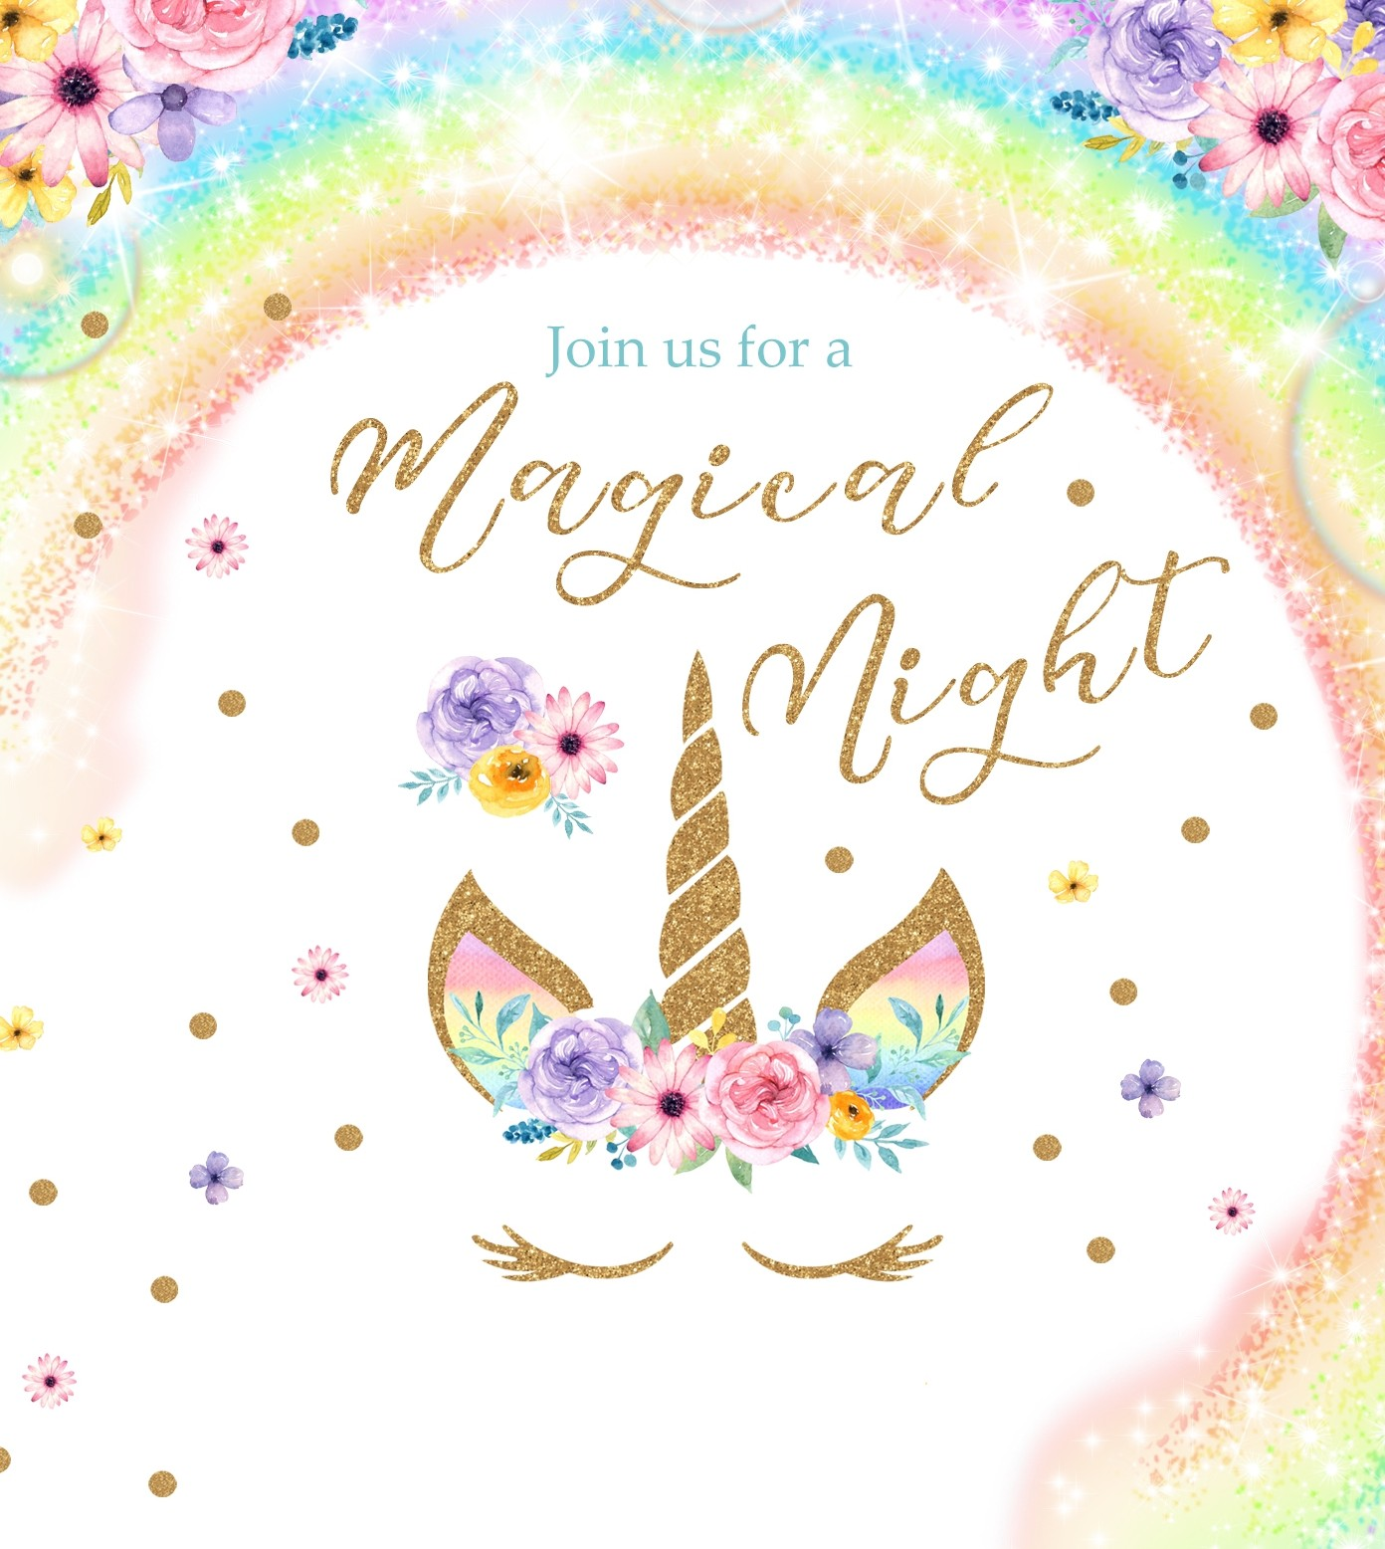

ADDISON JADE
IS TURNING TEN!
Saturday 12th February, 2022 4PM to 11AM
•
At Addison's House
•
•
With Little Miss Enchanted
1123 Unicorn Avenue, Rainsville
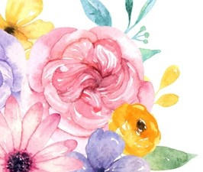
RSVP by 1st February, 2017 to Annabelle 0409 000 100
•
Bring Pillow and Sleeping Bag

